 | Hostel Management System  Technical Design Document
 | Prepared By / Last Updated By | Reviewed By | Approved By
Name
Role
Signature
Date

Table of Contents

1.0 Introduction 3
1.1 Purpose of this document 3
1.2 Project overview 3
2.0 Solution Summary 3
2.1 Scope 3
2.2 Assumptions 3
2.3 Dependencies 3
2.4 Risks 3
3.0 Schematic Diagram 3
4.0 System Design 4
4.1 Proposed design 4
4.2 Component inventory 4
5.0 Database Design 4
5.1 Data Model 4
5.2 Tables Structure 4
6.0 Appendices 4
6.1 Glossary 4
6.2 Other 5
7.0 Terms & Conditions 5
8.0 Change Log 5

Introduction

Purpose of this document
The purpose of this document is to document the technical design, component details and Database design. This will also capture the scope, assumptions, risk, dependencies of this project.

Project overview
The Hostel Management framework is a web application which is created for managing different activities in the hostel. This project is expected to limit human works and make hostel allocation much easier for student and hostel administrators with the help of the web application to hostel, naturally select the student from the waiting list and room booking, modification, complaint registration, and so forth.

Solution Summary

Scope
- Create and maintenance of admin login formation
- Maintenance of student registration information
- Maintenance of add room details information
- Maintenance of student’s details
- Maintenance of changing password created by user
- Maintenance of room booking information created by user
- Creation and maintenance of database to store information
- Creation and maintenance of views by admins

Assumptions
When the project will be completed,
Student users will be able to login or sign up. They will have option to reset password. They can be able to change they details and change password. Users will be able to book rooms with having two options i.e. A.C and NON-A.C rooms.
Admin can be able to see and confirm new booking and schedule them for some day(s) of the week, create new update which will be displayed in user home page. And to view all the user information and room booking information.

Dependencies
- Admin information has to be there in the database.
- User has to sign up first before any kind of integration.
- Room and general information have to present in the database.

Risks
Many users registration will be tedious to keep track on.

Schematic Diagram
A schematic, often known as a schematic diagram, is a depiction of a system's constituents using abstract, pictorial symbols rather than composite image. It provides an overview of the total system.
Use Case Diagram
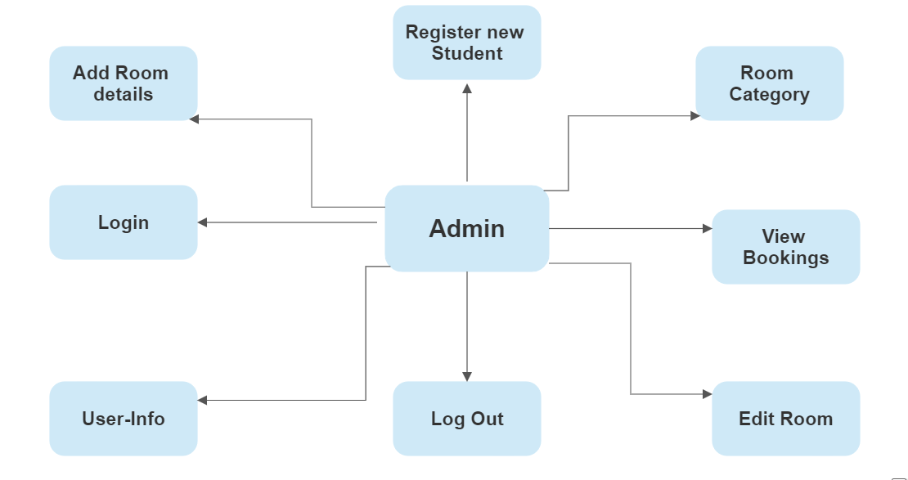

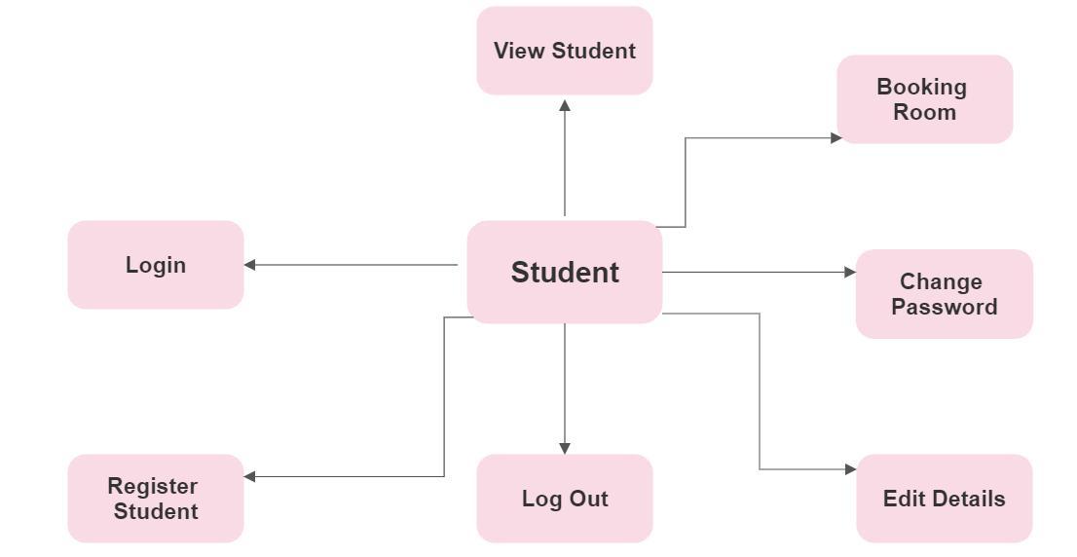

Admin and Student User Flow

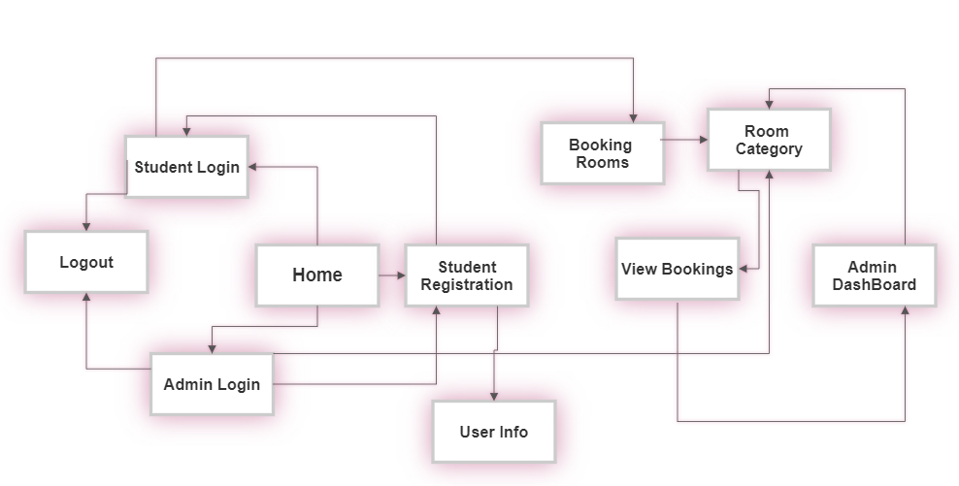

Models
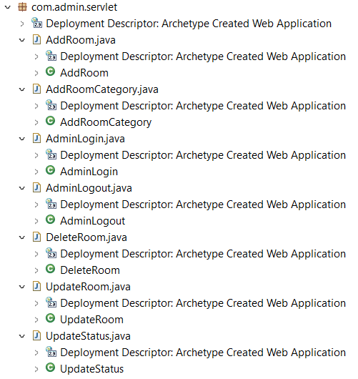

Database Connect

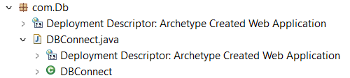

Room Servlet
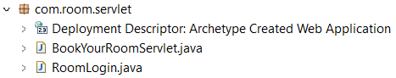

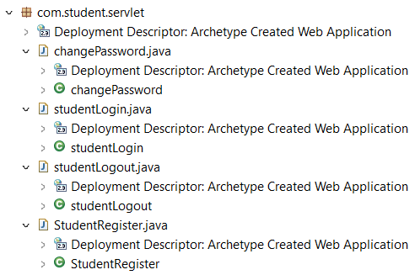
Student Servlet
Entity

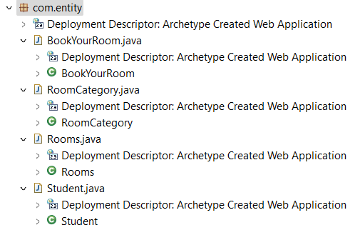
Data Access Objects

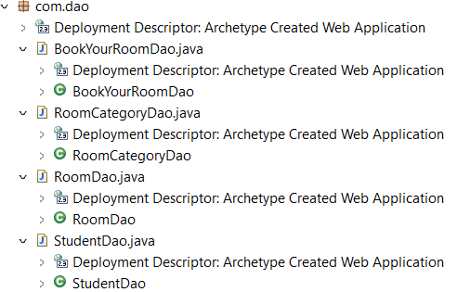

System Design

Proposed design
The functionality of the project is shared between two kinds of roles, admin and user.
Admin will be responsible for adding new student and confirmation for booking of hostel rooms. View all the booking information and Student user details. Admin can also be able to edit and register and view students and the booking details.
The user will be responsible for student registration, entering general information, and paying
Room booking fees. He or she will have access to all booking information as well as the
Option to see and edit profile information.

Component inventory
The project in consist of many layer of connected component which make sure a smooth flow of data. The project follows all the specification of MVC pattern.
- View: All the web pages which be visible to the end user, and that is the way for the user to interact with the application
- Servlet: A servlet is a programming model that is used to increase the capabilities of servers that host applications that are accessed using a request-response programming architecture.
- Service: Service layer is a middle ware between the database and controller to introduce an abstraction and it is also responsible for execute any kind of business logic required by the application.
- Data Access Object (DAO): Dao classes connect with databases and run queries.
- Model: Models contains information which is needed by all the above mentioned layers. All the layers interact with each other by models.

Database Design

Data Model

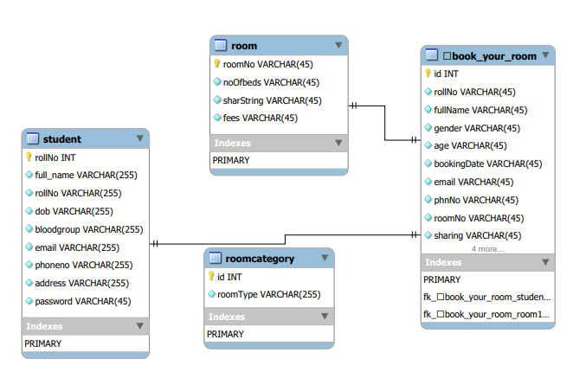

Tables Structure

Admin
Column Name | Data Type | Length | Nulls
Login ID | Varchar | 255 | Not null
Password | Varchar | 255 | Not null

Student
Column Name | Data Type | Length | Nulls
Student ID | Varchar | 255 | Not null
Password | Varchar | 255 | Not null

Book Your Room
Column Name | Data Type | Length | Nulls
RollNo | Int | 15 | Not null
FullName | Varchar | 45 | Not null
Gender | Varchar | 45 | Not null
Age | Varchar | 45 | Not null
Booking Date | Varchar | 45 | Not null
Email | Varchar | 45 | Not null
Phone No. | Varchar | 45 | Not null
Room No | Varchar | 45 | Not null
Sharing | Varchar | 45 | Not null
Address | Varchar | 45 | Not null
Status | Varchar | 45 | Not Null

Student
Column Name | Data Type | Length | Nulls
Roll No | Int | 11 | Not null
Full Name | Varchar | 255 | Not null
DOB | Varchar | 255 | Not null
Blood Group | Varchar | 255 | Not null
Email | Varchar | 255 | Not null
Phone No. | Varchar | 255 | Not null
Password | Varchar | 255 | Not Null

Room
Column Name | Data Type | Length | Nulls
Room No | Varchar | 45 | Not null
No of beds | Varchar | 45 | Not null
Room Type | Varchar | 45 | Not null
Sharing | Varchar | 45 | Not null
Fees | Varchar | 45 | Not null

Room Category
Column Name | Data Type | Length | Nulls
Id | Int | 11 | Not null
Room type | Varchar | 255 | Not null

Appendices

Glossary
Acronyms | Definitions

Other

Terms & Conditions
Disclaimer: Please do not circulate or distribute this document outside of Cognizant Network, We have a Zero Tolerance Policy. Kindly adhere to 100% Compliance at all times.

Change Log
Please note that this table needs to be maintained even if a Configuration Management tool is used.
Version Number | Changes made
V<n.n> | <If the change details are not explicitly documented in the table below, reference should be provided here>
V<n.n> | Page no | Changed by | Effective date | Changes effected

